Chapter 01, Python Programming Basics Lab

Objective
In this lab you'll use Visual Studio to create a Python application.
You will as a user input values using keyboard and display information.
You'll also use casting to convert strings to integers and floats.
Duration: 30 minutes. Please note there are three parts in this lab.

Part 1 - Display Hello World!

Objective
In this lab you'll use Visual Studio to create a Python application. Your code will display text to console. You'll then create two variables and display them within a sentence.

- Start Visual studio and create a Python application.
Name this application as Lab1 and take a good note of where it's saved.

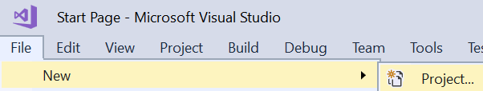

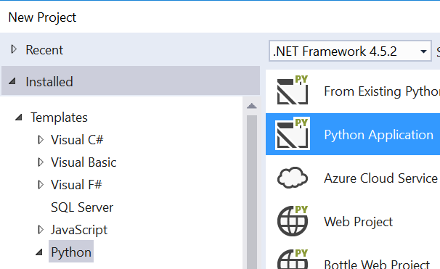

Note: If the option is not available, please follow the instruction below in steps a & b:
- Open Visual Studio and then click Tools 'Get Tools and Features…'
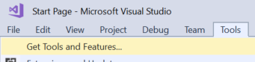
- Select Python from the list and then click the Modify button.
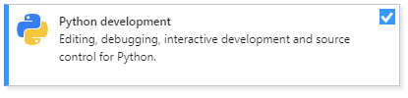
Note: You'll have to close the Visual Studio application because the Installer needs to modify it.
- Type the following text in the code page that is open:
print('Hello World!')
- Press ctrl-s to save.
- Press the F5 key to run.
- When the program stops running, press ctrl-F5 to run in non-debug mode.
Please note that it runs much faster.
We will discover the debugging feature of the development environment at a later date.

Part 2 - Display a message using variables
- Create two variables to hold someone's name and age.
In the code window, just below the last print() statement, type:
username='Bob'
age=32
print(username,'is',age,'years old')
- Press ctrl-s to save
- Press the key F5 to run
- Stop running the code and make the following changes.
- Modify your code to use the '+' character to add strings
username='Bob'
age=32
print(username+'is'+age+'years old')
- Press ctrl-s to save
- Press the key F5 or ctrl-F5 to run. ctrl-F5 runs a lot faster because it runs in non-debug mode (seen later).
- Does the output look right or strings are stuck together? That's what + and strings does!
Modify the print statement by inserting three spaces in the strings like:
print(username,' is '+age+' years old')
- Save and run your code
Please do not close this application. You'll add more code pages in part 2

Part 2 – Get user input

Objective
In this lab you'll add a new code page to the Lab 1 application.
You will also input values using keyboard.

Instructions
- Add a new code page to your project.
Right mouse click on the project's name and then add a new item as seen below:
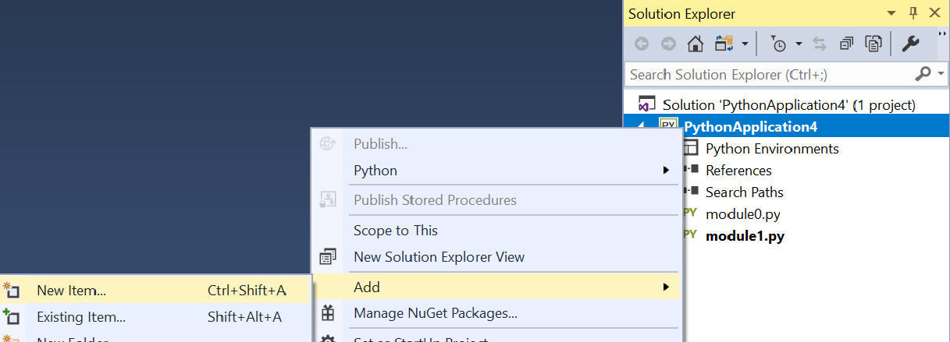
- Select the 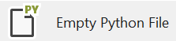 option and then give the file a suitable name.
- You'll need to make this page as your start up page.
Right mouse click on the file name and then click the 'Set as startup file' menu as seen below:
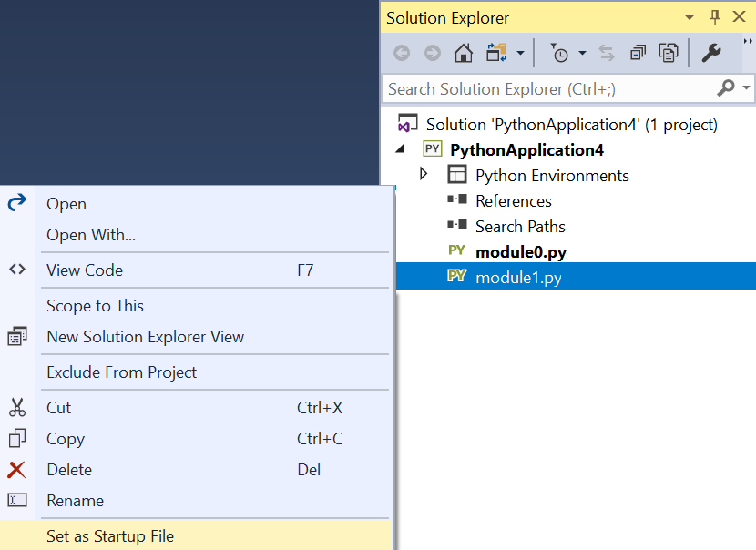
- Write the following code to get the username and age by using the keyboard.
username=input('Please enter your name')
age = input('Please enter your age')
print(username,'is',age,'years old')
- Save and run your code.

Part 3

Objective
In this lab you'll practice casting variables.
You will input text values using keyboard and cast (convert) these into numeric types.
You'll input the length and width of a rectangle and calculate the area and perimeter of the rectangle.

Step by step instructions
- Add a new code page to your Lab 1's project and make it the startup file.
Tip: Right mouse click on the project's name and then add a new item as seen in part-2.
- Input the length of the first side of a rectangle.
- Use a suitable variable name such as length.
You must cast (convert) the text you input to an integer type (int)
Tip: Please review the example code on the slides if you're not sure how to achieve this.
- Inputs the length of the second side of the rectangle.
Use a suitable variable name such as width.
Again, cast the input text to an integer type (int)
- Calculates and display the perimeter of the rectangle.
- Calculate and output the area of the rectangle.
- Save and run your code.

** End

